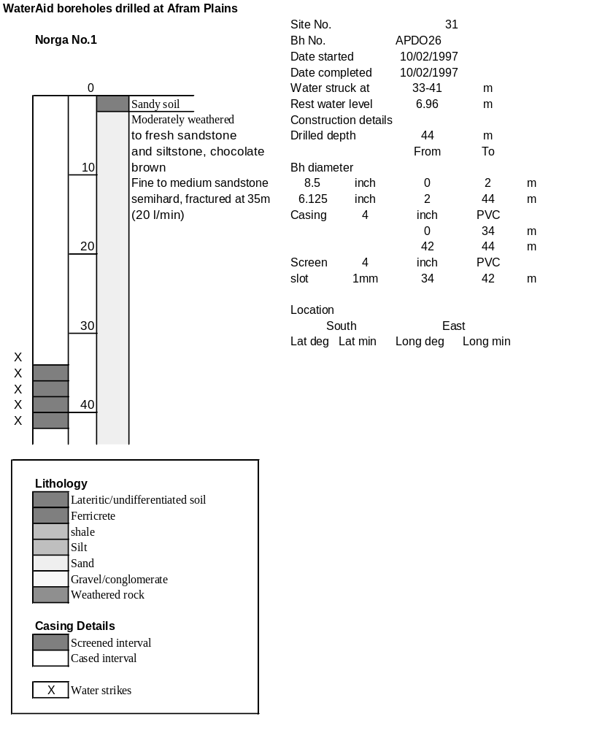

Ghana | Test pumping
Borehole No. |  | APDO 26
Hole No |  | 31
Village |  | Norga No1
Date |  | 15/02/1997
Point above GL |  | 0.5 | m
Pump depth |  | 32 | m
SWL |  | 6.96 | m
Start Time |  | 08:35
Drawdown test |  |  |  |  | Recovery Test
time | pwl (m) | Q l/min | dd | sc(q/s) | Time | wl (m) | t/t' | redd
0.00 | 6.96 | 24.00 | 0.00 |  | 0.00 | 29.08 |  | 22.12
1.00 | 11.59 | 24.00 | 4.63 | 5.18 | 1.00 | 26.15 | 181.00 | 19.19
2.00 | 13.60 | 24.00 | 6.64 | 3.61 | 2.00 | 23.64 | 91.00 | 16.68
3.00 | 15.35 | 24.00 | 8.39 | 2.86 | 3.00 | 21.27 | 61.00 | 14.31
4.00 | 16.80 | 24.00 | 9.84 | 2.44 | 4.00 | 19.09 | 46.00 | 12.13
5.00 | 18.11 | 24.00 | 11.15 | 2.15 | 5.00 | 17.45 | 37.00 | 10.49
6.00 | 19.12 | 20.00 | 12.16 | 1.64 | 6.00 | 16.16 | 31.00 | 9.20
7.00 | 19.71 | 20.00 | 12.75 | 1.57 | 7.00 | 15.11 | 26.71 | 8.15
8.00 | 20.33 | 20.00 | 13.37 | 1.50 | 8.00 | 14.30 | 23.50 | 7.34
9.00 | 20.84 | 20.00 | 13.88 | 1.44 | 9.00 | 13.63 | 21.00 | 6.67
10.00 | 21.40 | 20.00 | 14.44 | 1.39 | 10.00 | 13.02 | 19.00 | 6.06
11.00 | 21.91 | 20.00 | 14.95 | 1.34 | 12.00 | 11.99 | 16.00 | 5.03
12.00 | 22.39 | 20.00 | 15.43 | 1.30 | 14.00 | 11.14 | 13.86 | 4.18
13.00 | 22.74 | 20.00 | 15.78 | 1.27 | 16.00 | 10.36 | 12.25 | 3.40
14.00 | 23.11 | 20.00 | 16.15 | 1.24 | 18.00 | 9.72 | 11.00 | 2.76
15.00 | 23.46 | 20.00 | 16.50 | 1.21 | 20.00 | 9.16 | 10.00 | 2.20
16.00 | 23.98 | 20.00 | 17.02 | 1.18 | 22.00 | 8.67 | 9.18 | 1.71
17.00 | 24.06 | 20.00 | 17.10 | 1.17 | 24.00 | 8.26 | 8.50 | 1.30
18.00 | 24.32 | 20.00 | 17.36 | 1.15 | 26.00 | 7.95 | 7.92 | 0.99
19.00 | 24.52 | 20.00 | 17.56 | 1.14 | 28.00 | 7.71 | 7.43 | 0.75
20.00 | 24.70 | 20.00 | 17.74 | 1.13 | 30.00 | 7.52 | 7.00 | 0.56
22.00 | 25.02 | 20.00 | 18.06 | 1.11 | 35.00 | 7.28 | 6.14 | 0.32
24.00 | 25.27 | 20.00 | 18.31 | 1.09 | 40.00 | 7.24 | 5.50 | 0.28
26.00 | 25.48 | 20.00 | 18.52 | 1.08 | 45.00 | 7.21 | 5.00 | 0.25
28.00 | 25.68 | 20.00 | 18.72 | 1.07 | 50.00 | 7.20 | 4.60 | 0.24
30.00 | 25.85 | 20.00 | 18.89 | 1.06 | 60.00 | 7.17 | 4.00 | 0.21
35.00 | 26.40 | 20.00 | 19.44 | 1.03 | 70.00 | 7.15 | 3.57 | 0.19
40.00 | 26.94 | 20.00 | 19.98 | 1.00 | 80.00 | 7.13 | 3.25 | 0.17
45.00 | 27.30 | 20.00 | 20.34 | 0.98 | 90.00 | 7.12 | 3.00 | 0.16
50.00 | 27.60 | 20.00 | 20.64 | 0.97 | 100.00 | 7.10 | 2.80 | 0.14
55.00 | 27.81 | 20.00 | 20.85 | 0.96 | 110.00 | 7.09 | 2.64 | 0.13
60.00 | 27.88 | 20.00 | 20.92 | 0.96 | 120.00 | 7.09 | 2.50 | 0.13
70.00 | 27.99 | 20.00 | 21.03 | 0.95
80.00 | 28.04 | 20.00 | 21.08 | 0.95
90.00 | 28.21 | 20.00 | 21.25 | 0.94
100.00 | 28.40 | 20.00 | 21.44 | 0.93
110.00 | 28.54 | 20.00 | 21.58 | 0.93
120.00 | 28.66 | 20.00 | 21.70 | 0.92
130.00 | 28.74 | 20.00 | 21.78 | 0.92
140.00 | 28.83 | 20.00 | 21.87 | 0.91
160.00 | 28.97 | 20.00 | 22.01 | 0.91
180.00 | 29.08 | 20.00 | 22.12 | 0.90
